Which of the following reacts with $HNO_{3}$ $(H_{2}SO_{4})$gives nitration reaction at maximum rate?
A. 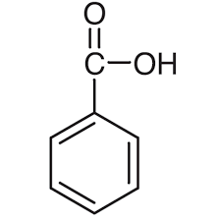
B. 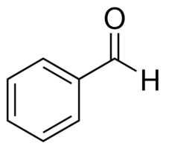
C. 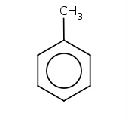
D. 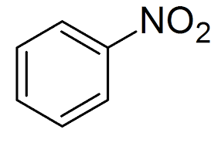
ANSWER: C
In which of the following reactions, the by product is HX?
A. Halogenation
B. Alkylation
C. Acylation
D. All of these
ANSWER: D

In which of the following electrophilic substitution reactions, water maybe the by-product?
A. Nitration
B. Alkylation
C. Acylation
D. Halogenation
ANSWER: A
In which of the following $NO_{2}^{+}$ is electrophile?
A. Nitration
B. Sulphonation
C. Alkylation
D. Halogenation
ANSWER: A
On electrophilic substitution of benzene_____ product is formed.
A. Monosubstituted
B. Disubstituted
C. Trisubstituted
D. All of these
ANSWER: A
The group that leaves on electrophilic substitution of benzene is _____
A. Carbon
B. Hydrogen
C. Carbon and hydrogen
D. None of these
ANSWER: B
Sulphonation means
A. Addition of $SO_{4}$
B. Addition of $SO_{2}$
C. Addition of $SO_{3}$
D. Addition of $H_{2}SO_{4}$
ANSWER: C
Which of the following catalysts are used in alkylation or acylation?
A. $AlX_{3}$
B. $H_{2}SO_{4}$
C. $FeX_{3}$
D. None of these
ANSWER: A
The catalyst used in halogenation of benzene is ____.
A. $AlX_{3}$
B. $H_{2}SO_{4}$
C. $FeX_{3}$
D. None of these
ANSWER: C
Which of the following is not Lewis acid?
A. $AlBr_{3}$
B. $H_{2}SO_{4}$
C. $FeCl_{3}$
D. $H_{2}O$
ANSWER: B
Alkyl benzene will form when benzene undergo_____.
A. Nitration
B. Sulphonation
C. Alkylation
D. Halogenation
ANSWER: C
Which of the following substitution reactions take place in benzene?
A. Free radical
B. Electrophilic substitution reaction
C. Nucleophilic substitution reaction
D. All of these
ANSWER: B
It activates the benzene ring.
A. Electron withdrawing deactivating group
B. Electron donating activating groups.
C. Electron donating deactivating group
D. Electron withdrawing activating group
ANSWER: C
Which of the following is isolated polycyclic?
A. Biphenyl
B. Naphthalene
C. Anthracene
D. All of these
ANSWER: A

It is also known as toluene.
A. 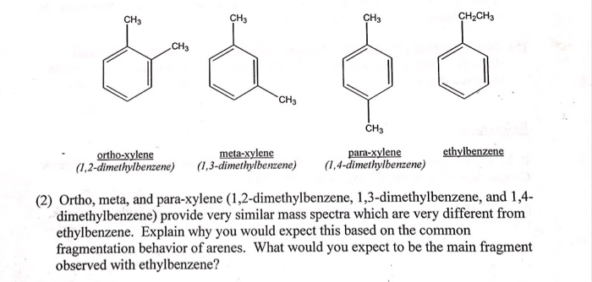
B. 
C. 
D. None of these
ANSWER: A

Which of the following molecule shows benzoic acid?
A. 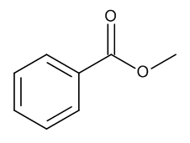
B. 
C. 
D. 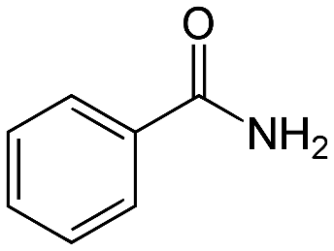
ANSWER: B

